**Kickstarter Analysis Report**

**Varun Athreya**

**8/14/2019**

1. Given the provided data, what are three conclusions we can draw about Kickstarter campaigns?

The provided data shows that almost 53% of Kickstarter campaigns are likely to be successful, 37% likely to fail and 8% gets cancelled. Theater, music, film and video have the highest success rate while food, games , publishing have low success rate. 33% gets cancelled in technology.

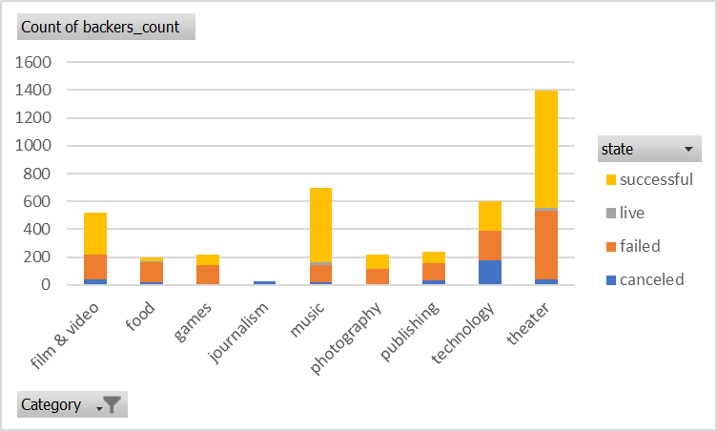

In looking at sub-categories classical music, documentary, electronic music, hardware, indie rock, metal, non-fiction, pop, radio & podcasts, shorts, small batch, tabletop games and television were completely 100% successful. Animation, children’s book, drama, fiction, food trucks gadgets, jazz, mobile games, people, nature, places, photo books, restaurants, videogames and were completely unsuccessful.

From March through May we see an increase in success and past May we have a steady decrease in success. The other notable point is that in the month December both success and failure intersect, and the failure count surpasses the successful count.

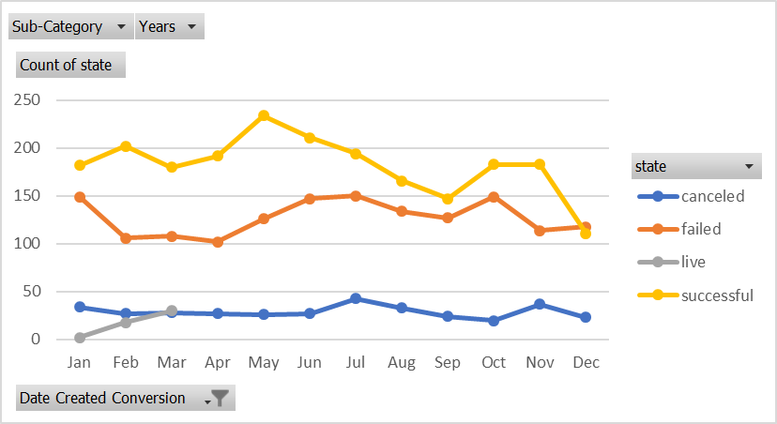

1. What are some limitations of this dataset?

The dataset is not large enough for some categories and subcategories. With a small sample size we cannot make relevant conclusions.

1. What are some other possible tables and/or graphs that we could create?

Just like how we analyzed using date created conversions we should also be using the date ended conversions to see if that provides additional trends. We should also be looking at data by states to see trends which have Kickstarter with the highest rates of success.